Leopard species and the Effect of Location

Alexis Moore

Evolution

Dr. Mitchell

April 5, 2023

INTRODUCTION

Melanism in leopards, *Panthera pardus*, manifests as dark coloring with dark spots (Kawanishi et al. 2010). Melanism is common in many species of leopard. Melanism can be observed in many different animals such as big cats and other felines (da Silva et al. 2017). Clouded leopards, *Neofelis nebulosa*, are a threatened species in the family Pantherinae with the other leopard species (Ghimirey and Acharya 2018). Clouded leopards are the oldest feline species having split before the other felines (Kitchener et al. 2016). Snow leopards, *Panthera uncia*, have very large ranges and tend to move around making them harder to study (Alexander et al. 2016).

Leopards and other big cats are studied using remote detection devices, like camera traps (Haidir et al. 2021). This is especially important due to the fact that humans have severely damaged the natural ranges of many leopard species (Wei Tan et al.). Humans hunt leopards and destroy their homes by cutting down forests and building roads (Hedges et al. 2015). The roads divide the populations of Malaysian leopards into smaller areas along with buildings. They also result in death due to collision (Hedges et al. 2015). The location of the population makes a huge difference to the types of leopards that can thrive there. Animals are adapted to survive in certain climates and surroundings. Without the necessary environment some leopards will begin to die off and other more suitable leopards will take their place.

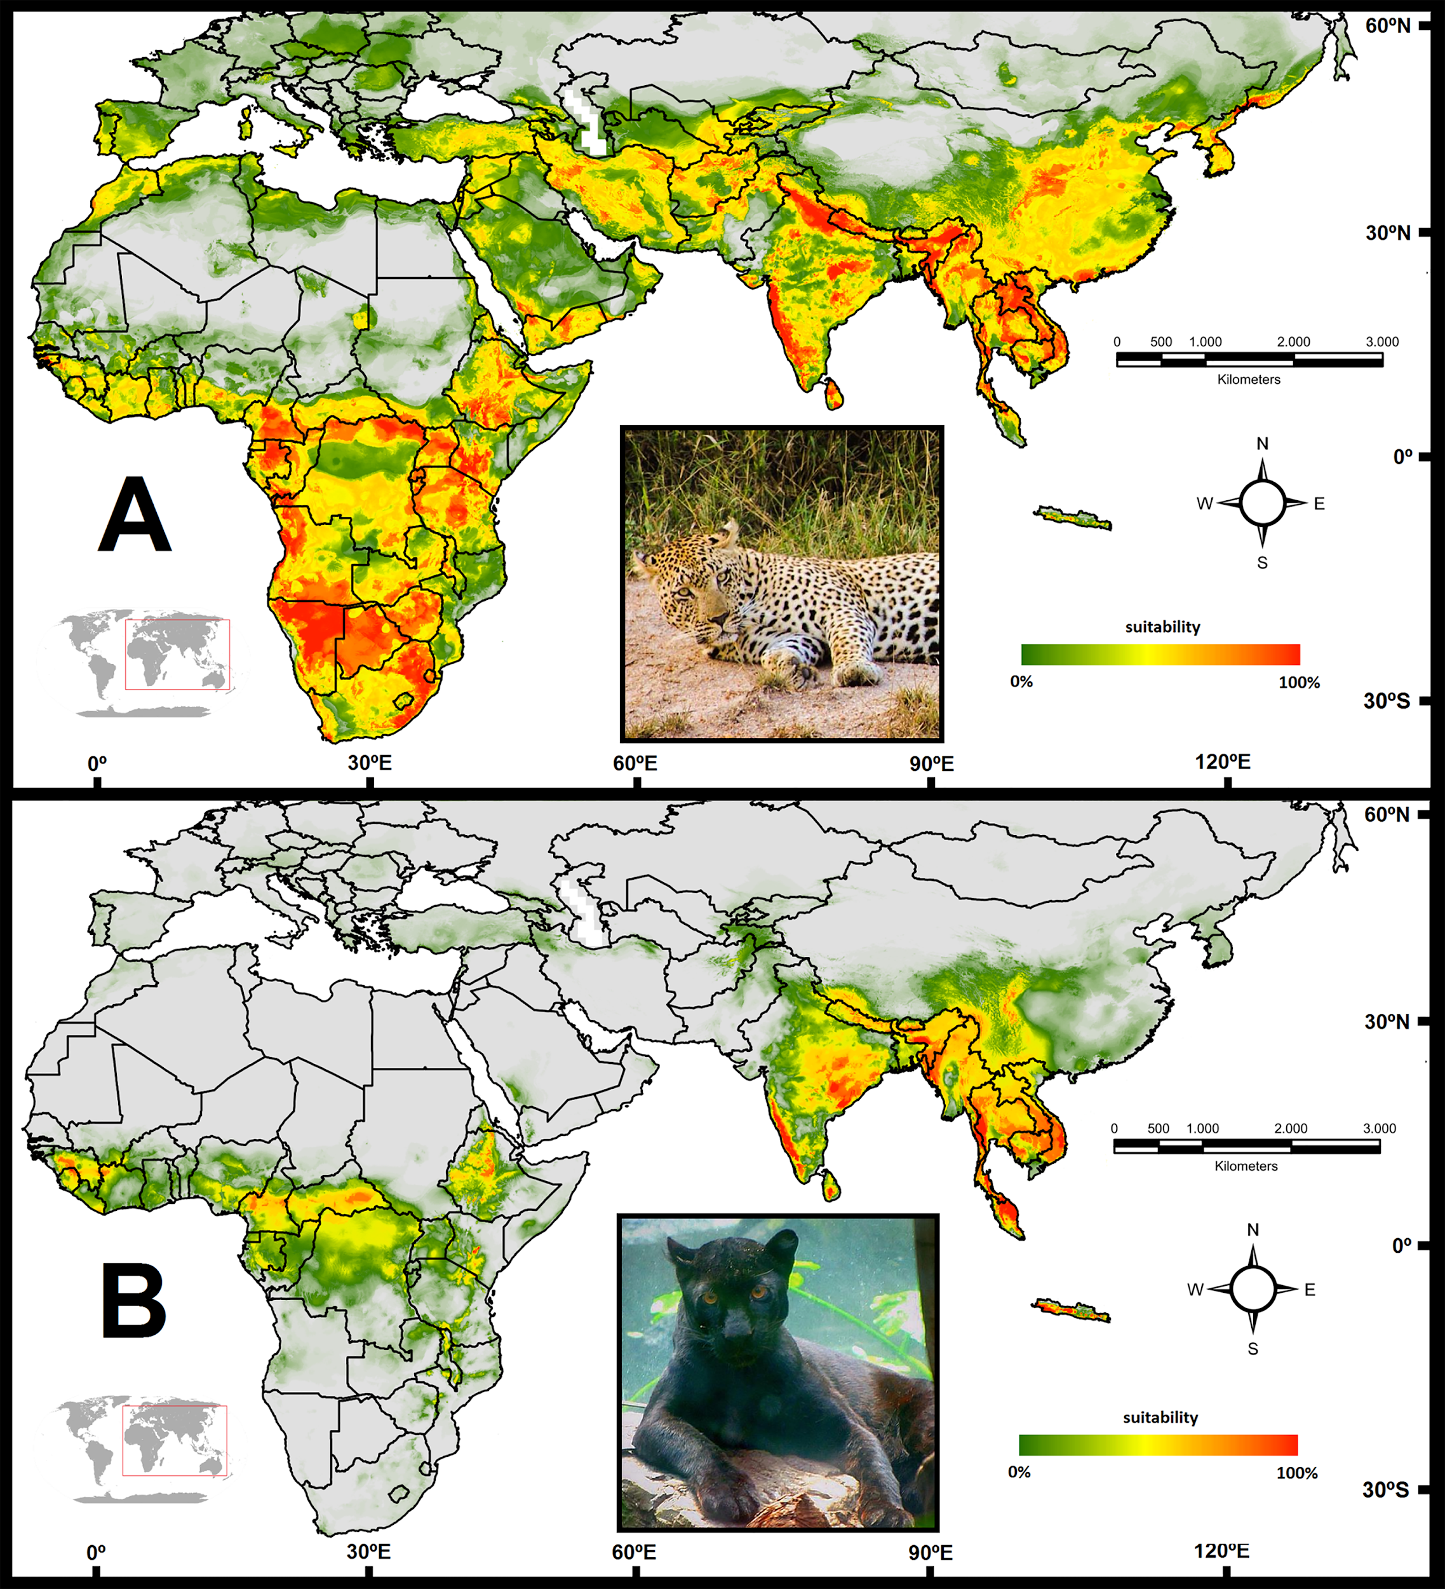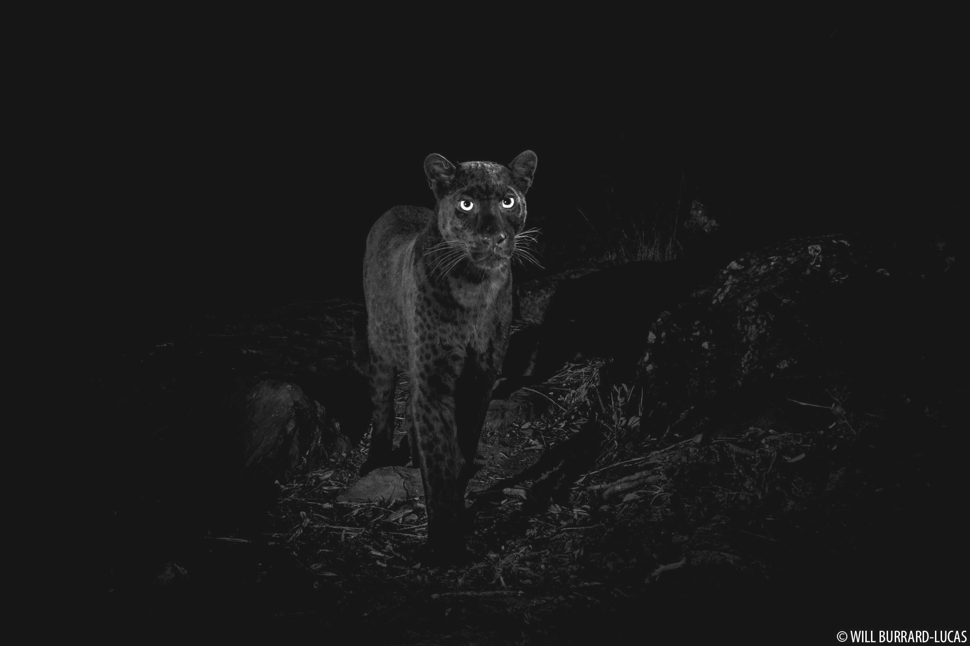

Figure 1: *Panthera pardus* (Left) with melanism (right) (Burrard-Lucas 2019; da Silva et al. 2017)

In this paper the location of 201 populations of leopard species was analyzed on a year to year basis. To determine if the location had an effect on the number of each species that inhabited each country. The types of leopard species in each country correlates to that country’s environment.

MATERIALS AND METHODS

The data used in this experiment was collected from many different papers found in the WVU Library Database. The majority of the data was collected from “Near fixation of melanism in leopards of the Malay Peninsula. Journal of Zoology.” and “Mapping black panthers: Macroecological modeling of melanism in leopards (Panthera pardus)” (Kawanishi et al. 2010; da Silva et al. 2017). This data was used to create the hypothesis and create the comparison between the different leopard species.

All of the graphs and the analysis of the different leopard species were calculated using excel. A one-way analysis of variance (ANOVA) was used with the four groups of leopards to determine if there was a significant difference between populations based on location. Four line graphs were created using this data. Each graph detailed a country and how many leopards were in that country over the years. These graphs are Figures 2-5.

RESULTS

The ANOVA test for leopard populations was calculated as df = 3, sum square = 120,717.5, mean square = 40239.16, F value = 11.72037, and the p value = 4.24E-07. The most snow leopards existed in 2017, and India had the most clouded leopards in 2015. South Africa had the most non-melanistic leopards in 2009. India has the most melanistic leopards. Bhutan, Cambodia, India, and Malaysia did not have any non-melanistic leopards. Myanmar and South Africa did not have any melanistic leopards. Siberia had the least snow leopards in 2017. Nepal had the least clouded leopards in 2015.

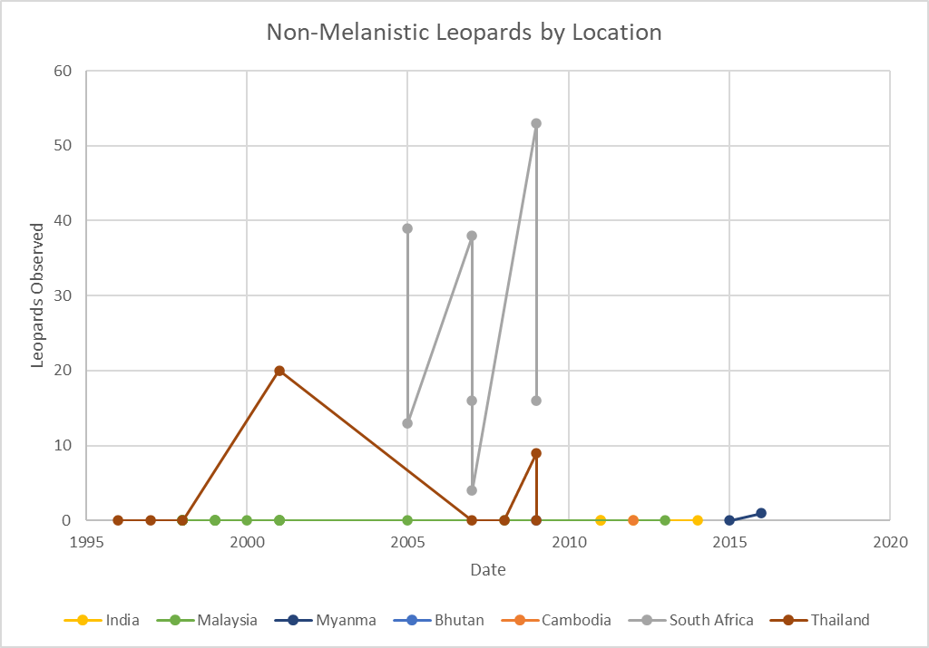

Figure 2: The change in the number of Non-Melanistic Leopards based on the location.

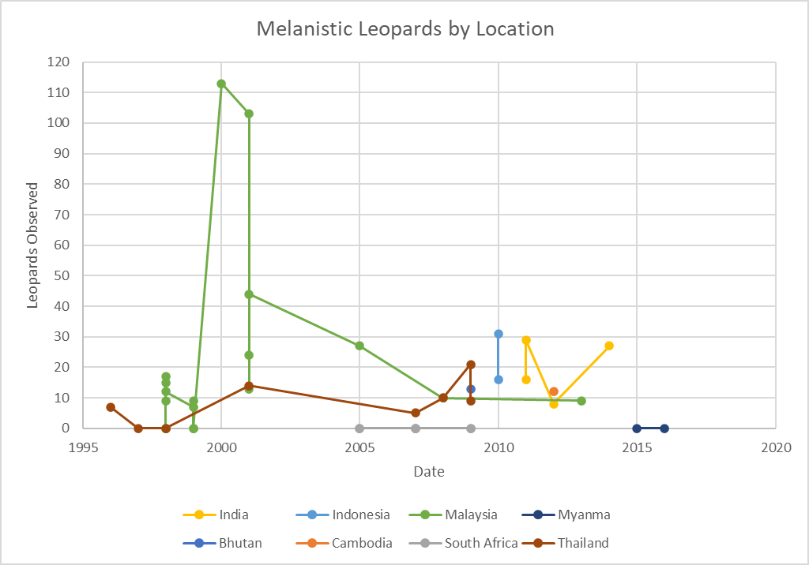

Figure 3: The change in the number of Melanistic Leopards based on the location.

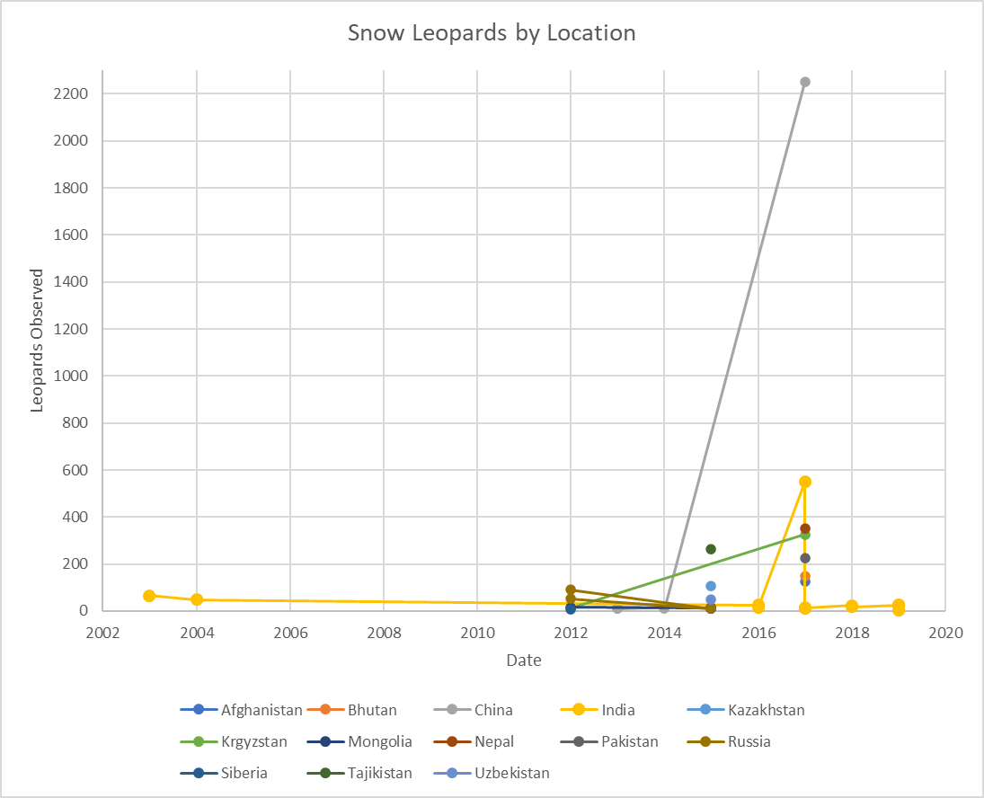

Figure 4: The change in the number of Snow Leopards by the location.

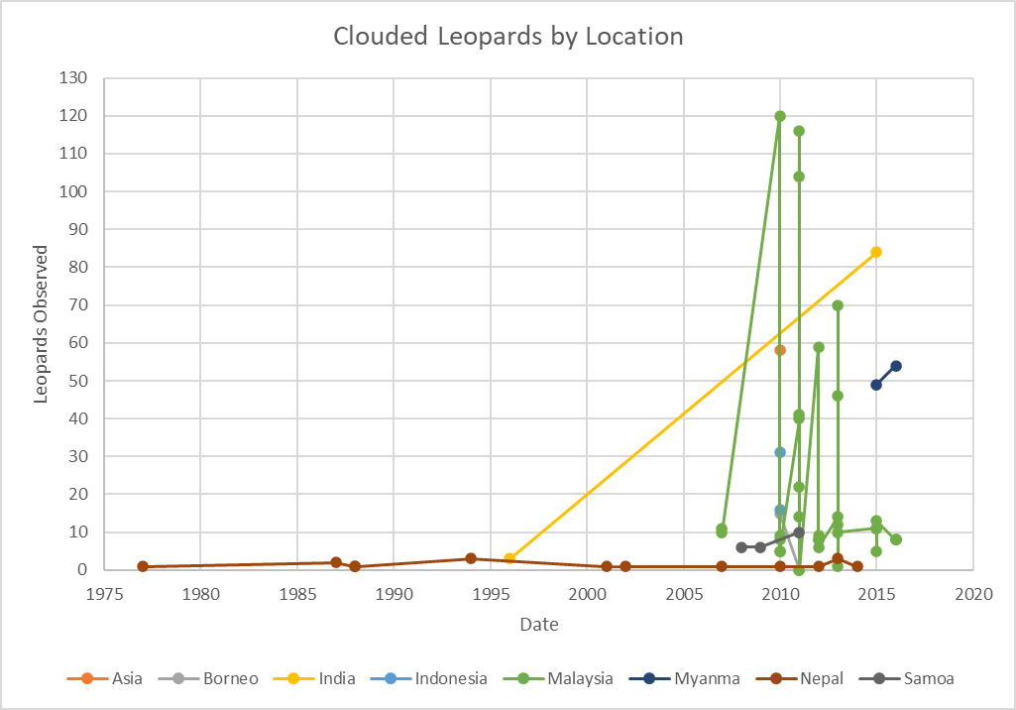

Figure 5: The change in the number of Clouded Leopards by the location.

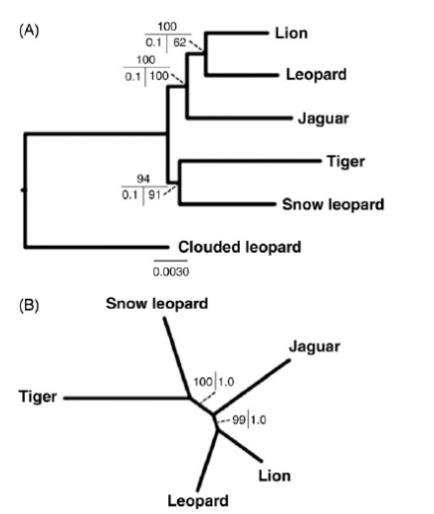

Figure 4: Maximum likelihood (ML) tree based on analysis of the complete supermatrix. (A) Rooted with clouded leopard as outgroup. 1000 ML bootstrap replicates percentages depicted on the top, Bayesian posterior probabilities (BPP) on the bottom left, and BEST posterior probabilities on the bottom right. (B) Unrooted topology with ML bootstrap percentages on the left and BPP on the right) (Kitchener et al. 2016).

DISCUSSION

Based on this data snow leopards prefer the cold mountainous regions of the country that range from -16\*C to 8\*C. Clouded leopards prefer lowland tropical rainforests. Melanistic leopards tend to occur in tropical & subtropical moist broadleaf forests. Non melanistic leopards seem to prefer tropical and subtropical grasslands. savannas, shrublands and moist broadleaf forests. Neither melanistic or non melanistic occurred very often in the tundra. This indicates that these leopards do not enjoy dry environments with little cover. The difference between populations was statistically significant.

The habitat of leopards has rapidly changed due to human interference and that change has had an impact on leopard populations. The data on the different species of leopards is limited due to the isolated nature of big cats, but the data that was collected suggests that although there is some overlap between leopard species they all seem to have a preferred location and environment that differs between them. There are a lot more snow leopards in India than there are clouded leopards suggesting that snow leopards are better suited for the ecosystem of India.

REFERENCES

Alexander JS, Zhang C, Shi K, Riordan P. 2016. A granular view of a snow leopard population using camera traps in Central China. Biological Conservation. 197:27–31. doi:10.1016/j.biocon.2016.02.023.

Balme G, Rogan M, Thomas L, Pitman R, Mann G, Whittington-Jones G, Midlane N, Broodryk M, Broodryk K, Campbell M, et al. 2019. Big cats at large: Density, structure, and spatio-temporal patterns of a leopard population free of anthropogenic mortality. Population Ecology. 61(3):256–267. doi:10.1002/1438-390X.1023.

Balme GA, Slotow R, Hunter LTB. Impact of conservation interventions on the dynamics and persistence of a persecuted leopard (Panthera pardus) population | Elsevier Enhanced Reader. doi:10.1016/j.biocon.2009.06.020.

Burrard-Lucas W. Black Leopard in Kenya. 2019. Burrard-Lucas.com, photos.willbl.com/galleries/15/. Accessed 18 Oct. 2020.

Ghimirey Y, Acharya R. 2018. The Vulnerable clouded leopard Neofelis nebulosa in Nepal: an update. Oryx. 52(1):166–170. doi:10.1017/S0030605316000582.

Haidir I, Macdonald DW, Linkie M. 2021. Sunda clouded leopard Neofelis diardi densities and human activities in the humid evergreen rainforests of Sumatra. Oryx. 55(2):189–196. doi:10.1017/S0030605319001005.

Hearn AJ, Ross J, Bernard H, Bakar SA, Goossens B, Hunter LTB, Macdonald DW. 2019. Responses of Sunda clouded leopard Neofelis diardi population density to anthropogenic disturbance: refining estimates of its conservation status in Sabah. Oryx. 53(4):643–653. doi:10.1017/S0030605317001065.

Hedges L, Lam WY, Campos-Arceiz A, Rayan DM, Laurance WF, Latham CJ, Saaban S, Clements GR. 2015. Melanistic leopards reveal their spots: Infrared camera traps provide a population density estimate of leopards in malaysia. The Journal of Wildlife Management. 79(5):846–853. doi:10.1002/jwmg.901.

Jackson RM, Roe JD, Wangchuk R, Hunter DO. 2006. Estimating Snow Leopard Population Abundance Using Photography and Capture-Recapture Techniques. Wildlife Society Bulletin. 34(3):772–781. doi:10.2193/0091-7648(2006)34[772:ESLPAU]2.0.CO;2.

Kawanishi K, Sunquist ME, Eizirik E, Lynam AJ, Ngoprasert D, Wan Shahruddin WN, Rayan DM, Sharma DSK, Steinmetz R. 2010. Near fixation of melanism in leopards of the Malay Peninsula. Journal of Zoology. 282(3):201–206. doi:10.1111/j.1469-7998.2010.00731.x.

Kitchener A, Driscoll C, Yamaguchi N. 2016. What is a Snow Leopard? Taxonomy, Morphology, and Phylogeny. p. 3–11.

Leki PT, Rajaratnam R, Shrestha R. 2018. Establishing baseline estimates of blue sheep (Pseudois nayaur) abundance and density to sustain populations of the vulnerable snow leopard (Panthera uncia) in Western Bhutan. wilr. 45(1):38–46. doi:10.1071/WR16218.

Loginov O, Loginova I. 2017. The snow leopard: the elusive ghost, but not yet lost, cat. A review of its conservation status in Siberia and Central Asia. International Journal of Environmental Studies. 74(5):903–914. doi:10.1080/00207233.2017.1341721.

Mohamed A, Sollmann R, Wong ST, Niedballa J, Abrams JF, Kissing J, Wilting A. 2021. Counting Sunda clouded leopards with confidence: incorporating individual heterogeneity in density estimates. Oryx. 55(1):56–65. doi:10.1017/S0030605318001503.

Naing H, Ross J, Burnham D, Htun S, Macdonald DW. 2019. Population density estimates and conservation concern for clouded leopards Neofelis nebulosa , marbled cats Pardofelis marmorata and tigers Panthera tigris in Htamanthi Wildlife Sanctuary, Sagaing, Myanmar. Oryx. 53(4):654–662. doi:10.1017/S0030605317001260.

Pal R, Sutherland C, Qureshi Q, Sathyakumar S. 2022. Landscape connectivity and population density of snow leopards across a multi-use landscape in Western Himalaya. Animal Conservation. 25(3):414–426. doi:10.1111/acv.12754.

Poyarkov AD, Munkhtsog B, Korablev MP, Kuksin AN, Alexandrov DY, Chistopolova MD, Hernandez‐Blanco JA, Munkhtogtokh O, Karnaukhov AS, Lkhamsuren N, et al. 2020. Assurance of the existence of a trans‐boundary population of the snow leopard (Panthera uncia) at Tsagaanshuvuut – Tsagan‐Shibetu SPA at the Mongolia–Russia border. Integrative Zoology. 15(3):224–231. doi:10.1111/1749-4877.12420.

Ross J, Hearn AJ, Johnson PJ, Macdonald DW. 2013. Activity patterns and temporal avoidance by prey in response to Sunda clouded leopard predation risk. Journal of Zoology. 290(2):96–106. doi:10.1111/jzo.12018.

Schneider A, David VA, Johnson WE, O’Brien SJ, Barsh GS, Menotti-Raymond M, Eizirik E. 2012. How the Leopard Hides Its Spots: ASIP Mutations and Melanism in Wild Cats. Murphy WJ, editor. PLoS ONE. 7(12):e50386. doi:10.1371/journal.pone.0050386.

Sharief A, Kumar V, Singh H, Mukherjee T, Dutta R, Joshi BD, Bhattacharjee S, Ramesh C, Chandra K, Thakur M, et al. 2022. Landscape use and co-occurrence pattern of snow leopard (Panthera uncia) and its prey species in the fragile ecosystem of Spiti Valley, Himachal Pradesh. PLoS ONE. 17(7):1–18. doi:10.1371/journal.pone.0271556.

Sharma K, Bayrakcismith R, Tumursukh L, Johansson O, Sevger P, McCarthy T, Mishra C. 2014. Vigorous Dynamics Underlie a Stable Population of the Endangered Snow Leopard Panthera uncia in Tost Mountains, South Gobi, Mongolia. PLoS ONE. 9(7):1–10. doi:10.1371/journal.pone.0101319.

da Silva LG, Kawanishi K, Henschel P, Kittle A, Sanei A, Reebin A, Miquelle D, Stein AB, Watson A, Kekule LB, et al. 2017. Mapping black panthers: Macroecological modeling of melanism in leopards (Panthera pardus). Murphy WJ, editor. PLoS ONE. 12(4):e0170378. doi:10.1371/journal.pone.0170378.

Singh P, Macdonald DW. 2017. Populations and activity patterns of clouded leopards and marbled cats in Dampa Tiger Reserve, India. Journal of Mammalogy. 98(5):1453–1462. doi:10.1093/jmammal/gyx104.

Wei Tan CK, Rocha DG, Clements GR, Brenes-Mora E, Hedges L, Kawanishi K, Mohamad SW, Rayan DM, Bolongon G, Moore J. 2017. Habitat use and predicted range for the mainland clouded leopard Neofelis nebulosa in Peninsular Malaysia. Biological Conservation. 206: 65-74. doi:10.1016/j.biocon.2016.12.012.